Learning Management System

**Use-Case Specification:** Manage Courses

**Version 1.0**

**Revision History**

| **Date** | **Version** | **Description** | **Author** |
| --- | --- | --- | --- |
| 27/11/2024 | 1.0 | Final version | Nguyễn Thị Hiền Anh |

**Table of Contents**

1. Manage Course 4

1.1 Brief Description 4

2. Flow of Events 4

2.1 Basic Flow

2.1.1. Access and View Management View

2.1.2. Create a course

2.1.3. Edit courses

2.1.4. Delete courses 4

2.2 Alternative Flows 9

3. Derived Requirements 9

**Use-Case Specification:** Manage Courses

# Manage Courses

## **Brief Description**

The Manage Course use case allows administrators to create, update, and delete courses in the LMS. It includes assigning members (students and instructors) to courses and ensuring course information is correctly managed.

# **Flow of Events**

## **Basic Flow**

* + 1. **Access and View Management View**

Initiate the Course Management View and choose the page number to see more courses.

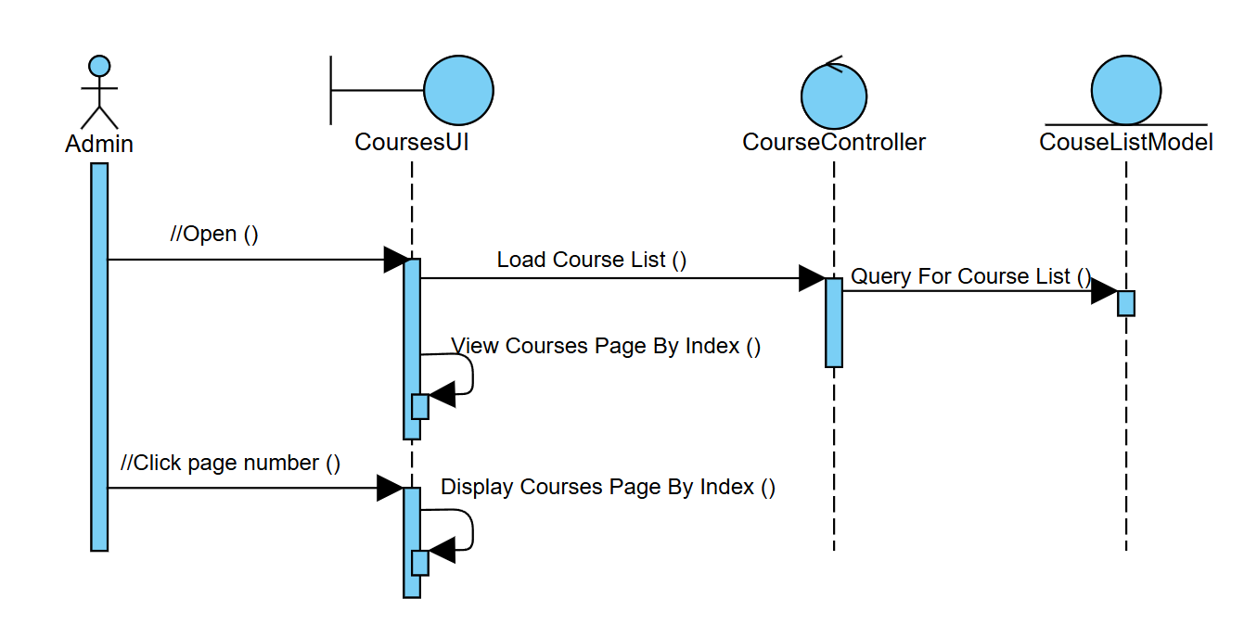

Search for courses by keywords, including Course Name and Course ID.

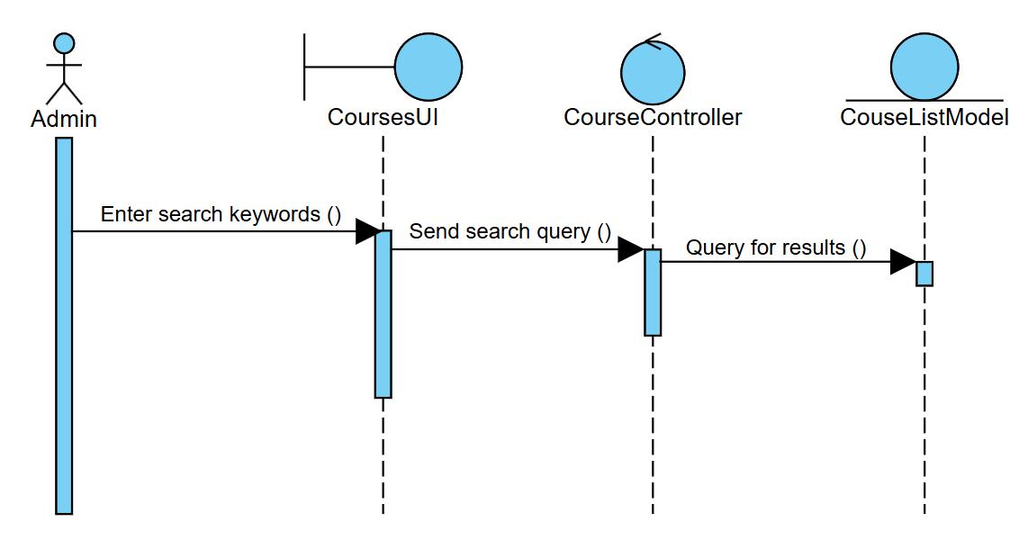

The admin can sort the course based on references (latest-oldest; oldest-latest; recently added)

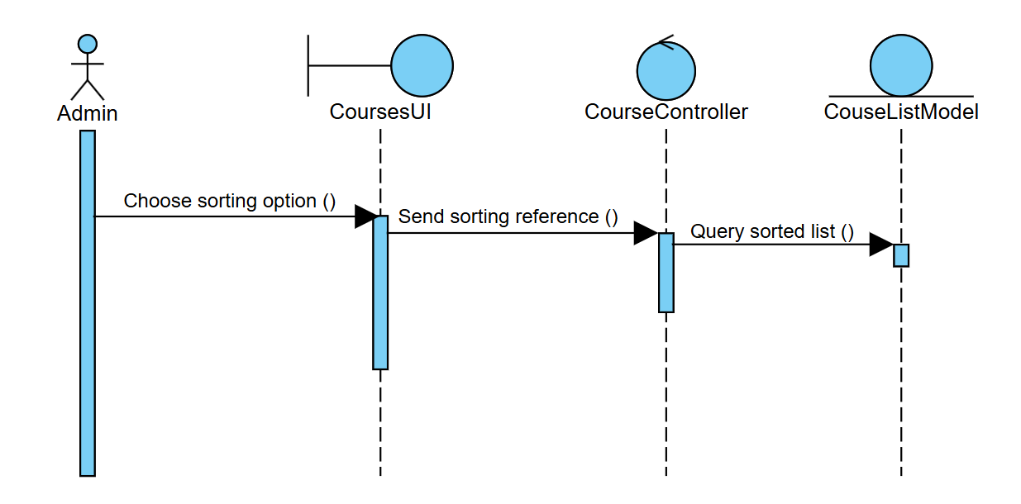

The admin can view course details when clicking the “View” button, but is not allowed to edit in this view.

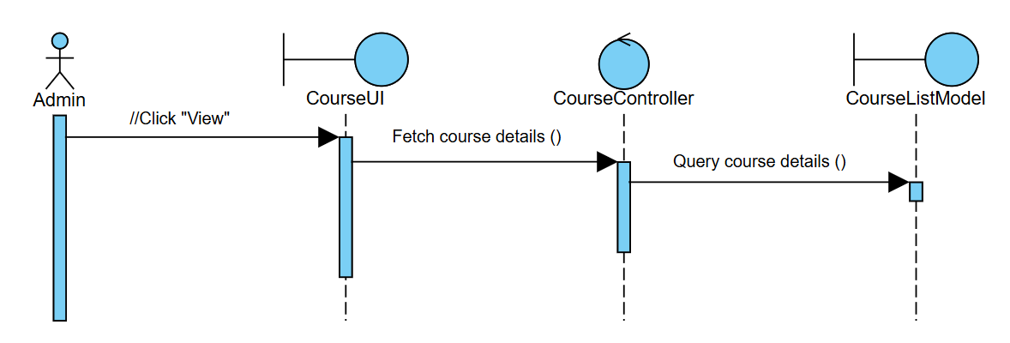

* + 1. **Create a course**

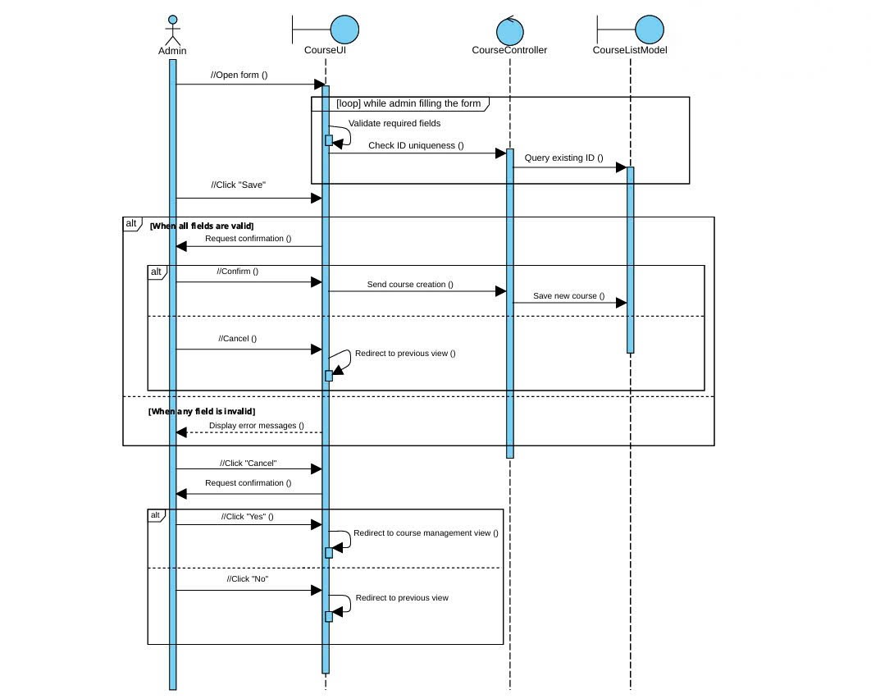

The flow below is adjusting the member list of the course. The user model will be fetched automatically and suggested to the admin when the admin types the user ID in. The admin will choose the account from the suggestion. This member list is included in the form

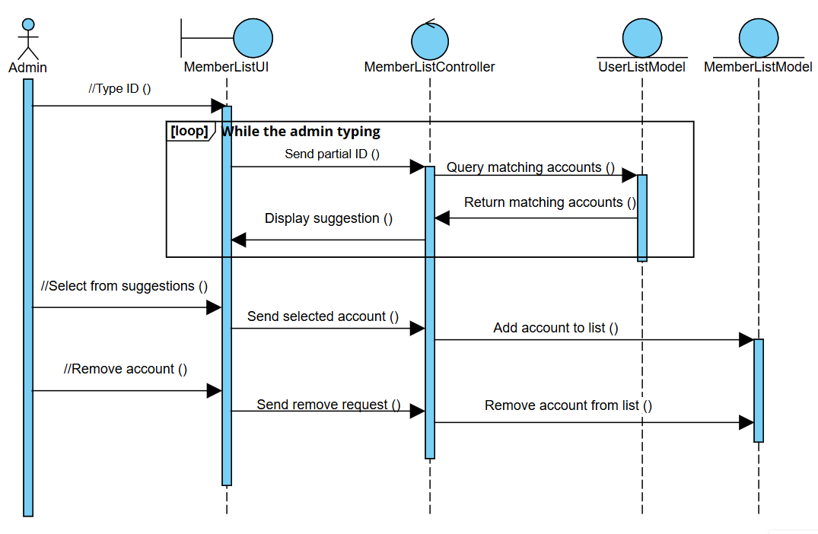

* + 1. **Edit courses**

The flow of editing courses is similar to creating courses; the admin must fill in the required fields so he/she is not allowed to delete data from those fields and let them empty. The course ID might be changed but still needs to be unique so there are still validation and checking uniqueness processes constantly while the admin is typing in the form and edit information in the form.   
The admin can also adjust the member list as in creating a course by adding or removing a member account from the list.

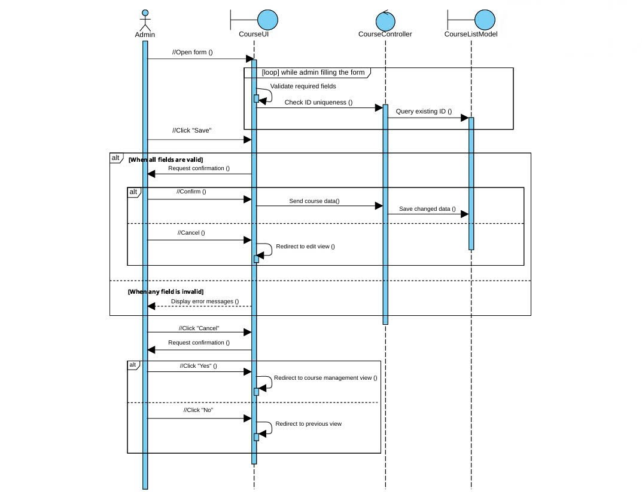

* + 1. **Delete courses**

When the admin hovers on the card, the three buttons will appear, including the “Delete” button. When the admin clicks that button, the system must check if the course has ended yet; if it hasn’t, the course is not allowed to be deleted. If it is ended, the system will pop up a confirmation whether the admin really wants to delete the course and only delete the course when the admin confirms again to.

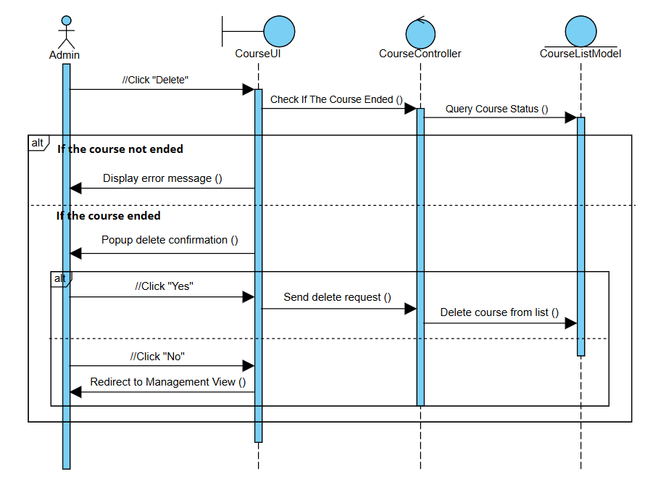

## **Alternative Flows**

NA.

# Derived Requirements

NA.